Agricultural Safety Education Initative

Tabletop and Field Identification of Tractor Controls – Facilitator Copy

Introduction: This exercise is to help your participants understand how to correctly and safety identify tractor operation controls. Using the materials listed, complete the activity with your students and discuss the results afterwards.
Objective: Help students identify the tractor operations controls.
Materials Needed: Picture or drawing of tractor operation controls (i.e. Tractor owners’ manual), Clear page protectors, Dry erase or wet erase color markers, modern tractor and tractor owner’s manual.

- Briefly explain the activity to the participants- give them directions on how to use the materials and how they are going to complete the activity on the worksheet.
- Allow them 15-20 minutes to finish the activities on the worksheet.
- Using 5 minutes or less, discuss the results of the participants and what they can interpret from this exercise.

Discussion Questions to Consider:
- What kind of precautionary measures should you take when starting, stopping, or moving tractors and machinery?
- What seat checks should be completed before starting the equipment?
- How should you mount and dismount the tractor?
- What PPE should be worn when operating a tractor?
- What safety equipment should the tractor be equipped with?

Tabletop and Field Identification of Tractor Controls - Student Copy

Introduction: This exercise is to help you understand the importance of identifying tractor operation controls, mounting, dismounting, and pre-op checks prior to starting the tractor. Using the materials, follow the steps below to complete the skill activity.

Materials: Picture or drawing of tractor operation controls (i.e. Tractor owners’ manual), Clear page protectors, Dry erase or wet erase color markers, and tractor owner’s manual.

Content: The American Society of Agricultural & Biological Engineers (ASABE) has published standards for tractor controls. The four main groups of color-coded controls are discussed below.
Commit this color code to memory. You will use this information to operate a modern tractor.
Color Coding for Controls -
- RED color = STOP ENGINE. Single-function engine stop controls, where key switches, ignition switches or hand throttles are used to stop the engines, the “off” of “stop” positions shall be indicated with red letting and/or symbols.
- ORANGE color = GROUND MOTION. Machine ground motion controls only (examples: engine speed, PARK-Lock, transmission). Exception One: where the engine speed and engine stop controls are combined, the controls may be red. Exception Two: Steering wheels or steering controls may be black or any color other than red or yellow.
- YELLOW color = POWER ENGAGEMENT OF MECHANISMS. Function controls which involve the engagement of mechanisms only (examples: engage PTO, cutterheads, unloading augers or remote power sources).
- BLACK color (or any other color except red, orange, or yellow) = POSITIONING AND ADJUSTING. Controls used for tractor functions that are not listed under red, orange, or yellow (examples: choke the engine, turn lights on, hitch lift, header high, reel lift).
Remember that older tractors may not use these colors, or you may not be able to see them. If the tractor you need to use does not have color controls, take time to learn about the controls on that tractor. Review the owner’s manual.

Activity:
Step 1: Develop an acronym to help you remember the function of each control color.
__________________________
__________________________
__________________________
__________________________

Step 2: Use markers provided to color code operator controls in the picture provided.
- Do not remove the picture from the page protector. Color on the page protector. Have your instructor review your work and initial below. Use a cloth to remove the marker from the page protector after your instructor has reviewed your color-coding.
  - Instructor verified initial__________________

Step 3: With tractor used for the operations skills test, you will need to complete a pre-operation inspection and tractor entry.
- Review the pre-op/driving test evaluation form. Once in the tractor seat, review the controls of the tractor that will be used for the operations skills test. Identify the function of each control.

Discuss this activity with your instructor and identify ways to keep yourself safe around tractors and machinery.

Color Coding Tractor Operation Controls Worksheet

Directions: Use the correct color to fill in each letter bubble in the pictures below. A key is provided below for each letter. Some letter bubbles may be left blank.

Picture One:
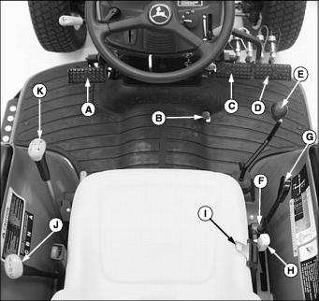

Picture One KEY:
A - Clutch Pedal
B - Engine Speed Foot Throttle
C - Left Turn Brake Pedal
D - Right Turn Brake Pedal
E - Selective Control Valve (SCV) Lever
F - Rockshaft Adjustable Depth Stop Knob
G - Rockshaft Control Lever
H - PTO Control Lever
I - Seat Belt
J - Transmission Range Shift Lever
K - Transmission Gear Shift Lever

Continue on next page….

Picture Two:
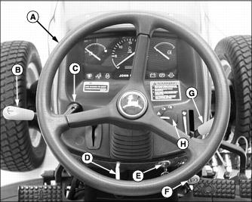
Picture Two KEY:
A - Steering Wheel
B - Reverser Lever
C - Turn Signal Lever
D - Tilt Steering Control Lever
E - Ignition Key Switch
F - Park Brake Lock
G - Engine Speed Hand Throttle
H - Light Control Switch

